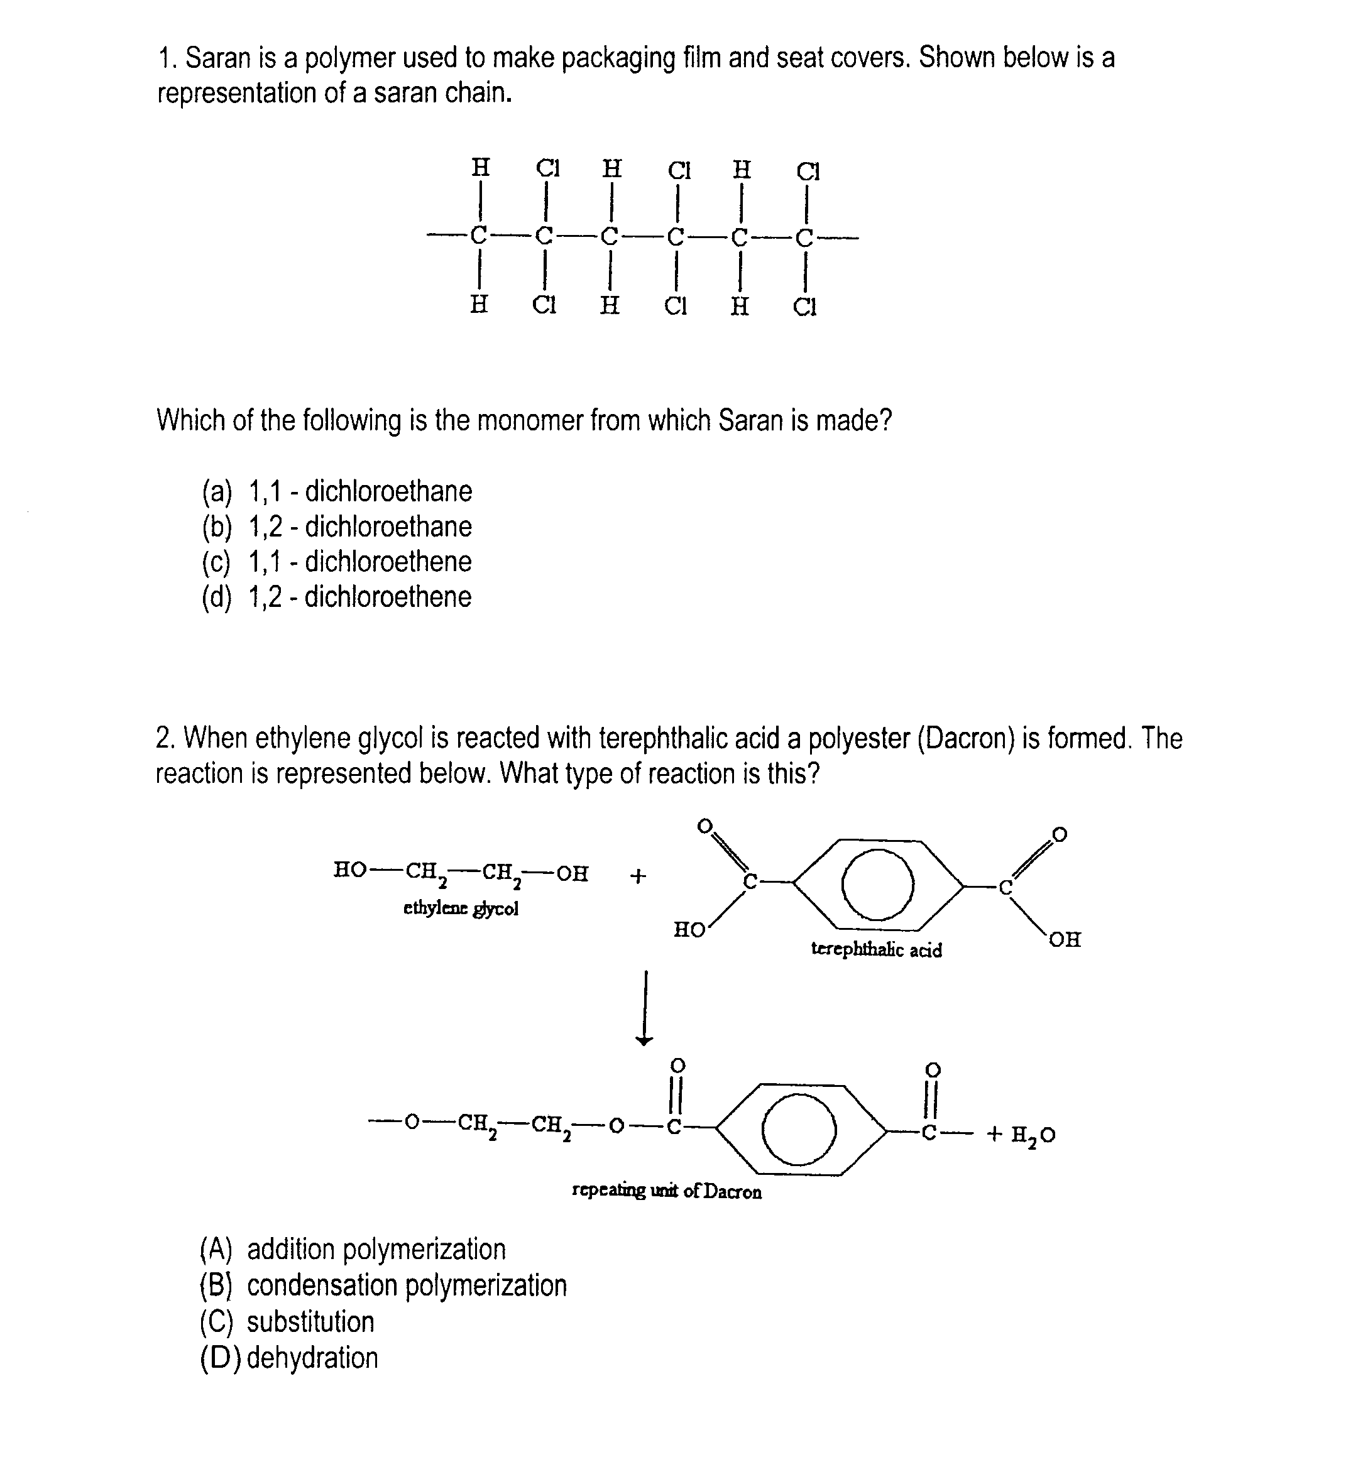
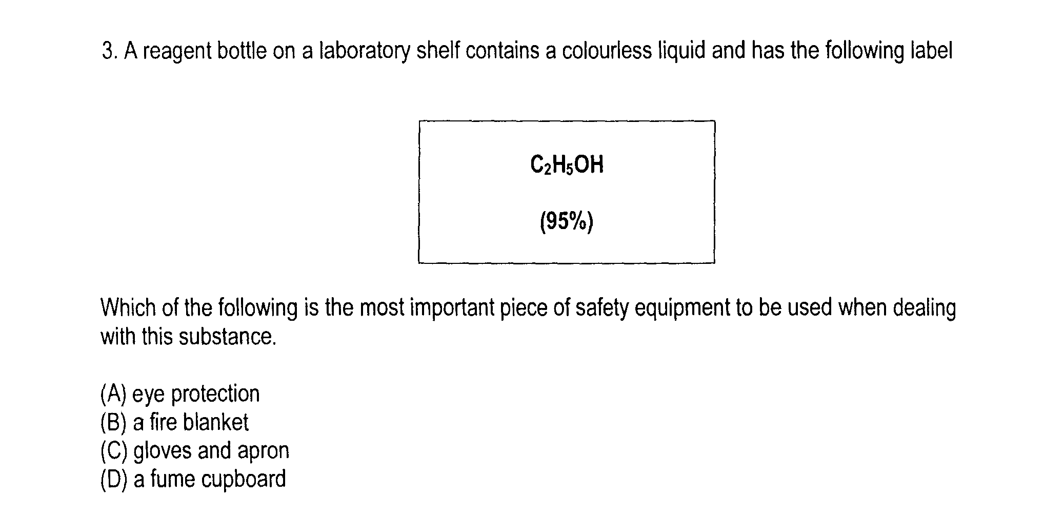
HOLY SPIRIT – YEAR 12 HALF YEARLY – 2008

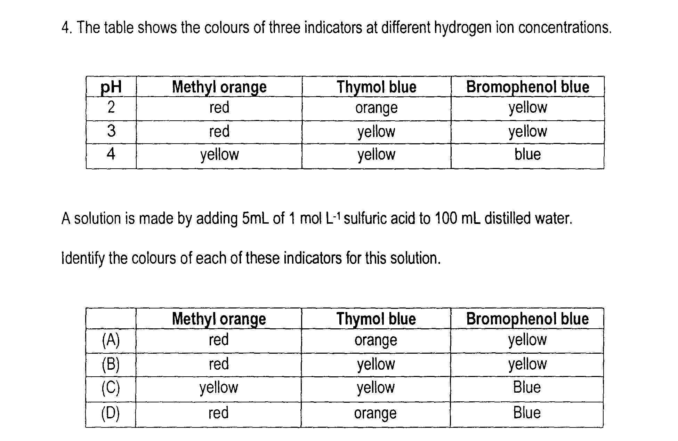

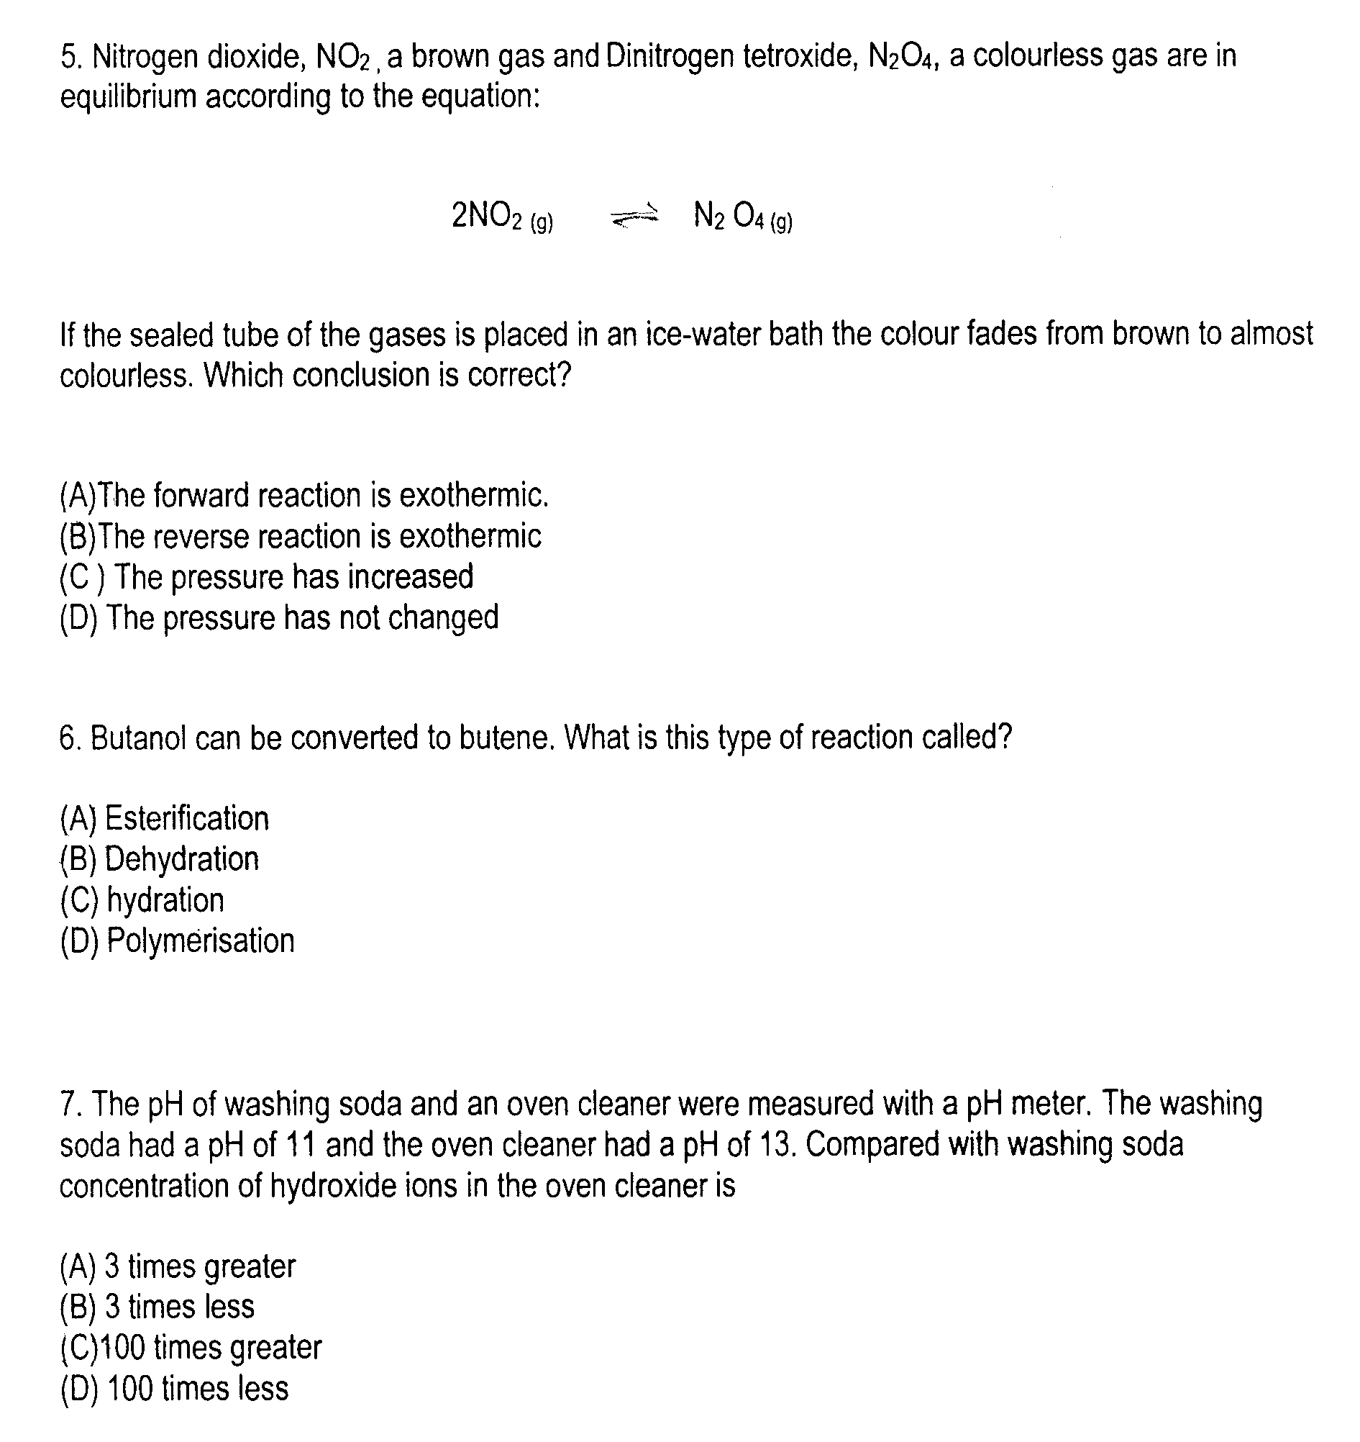

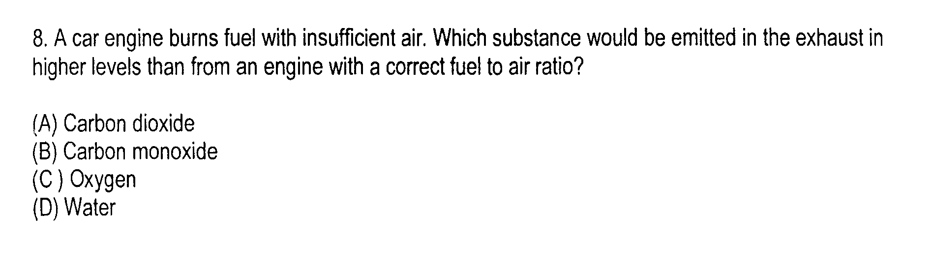

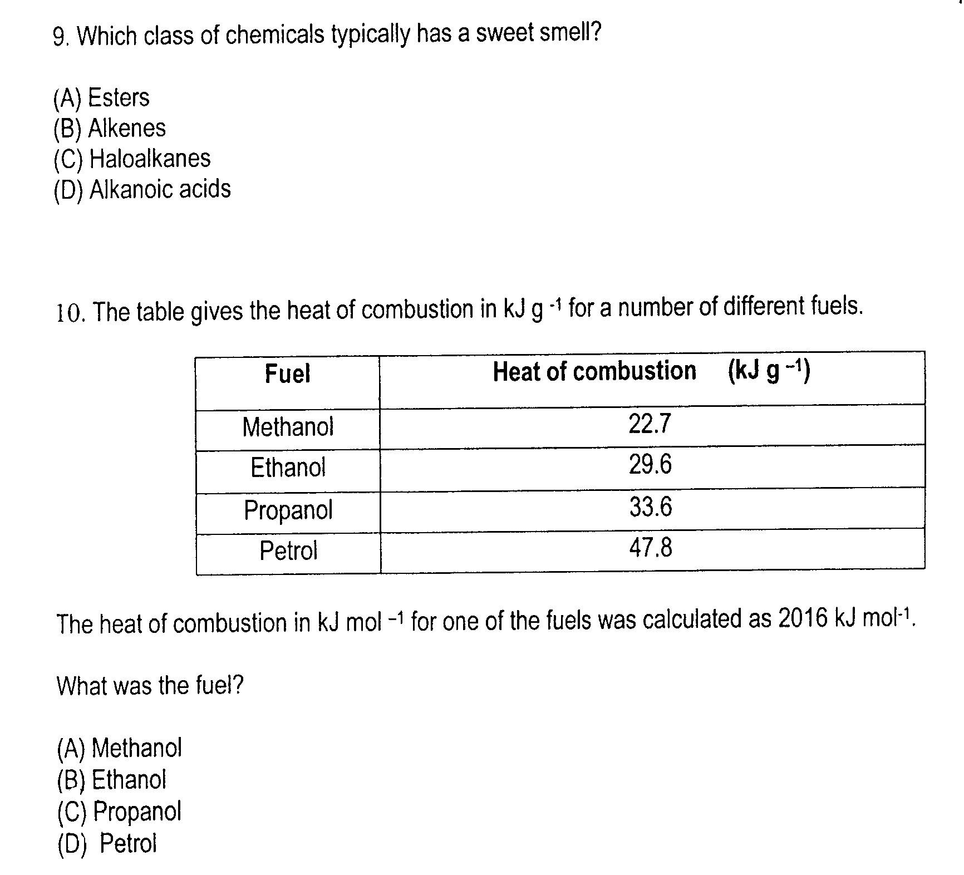

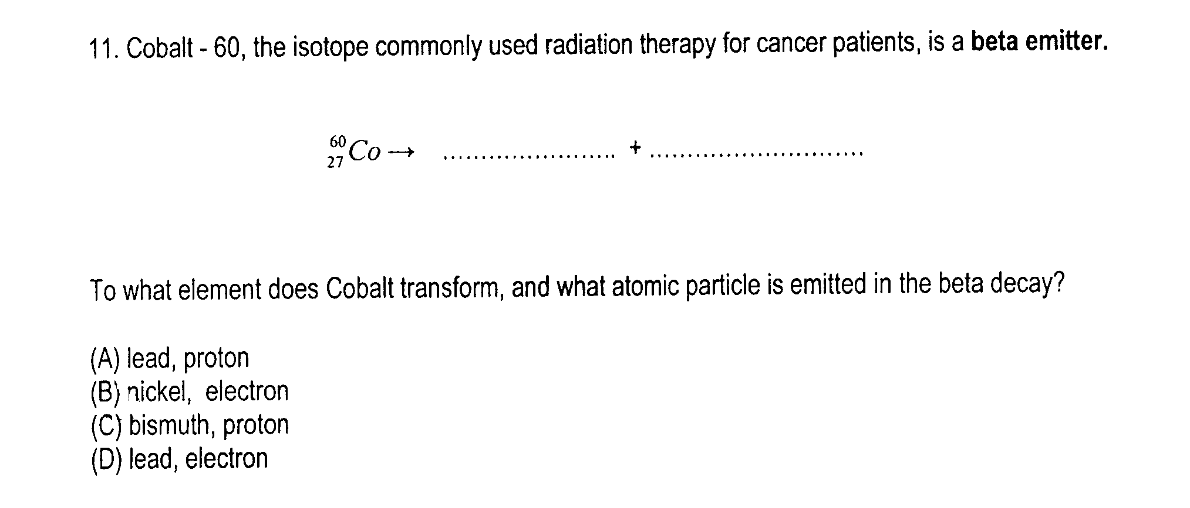

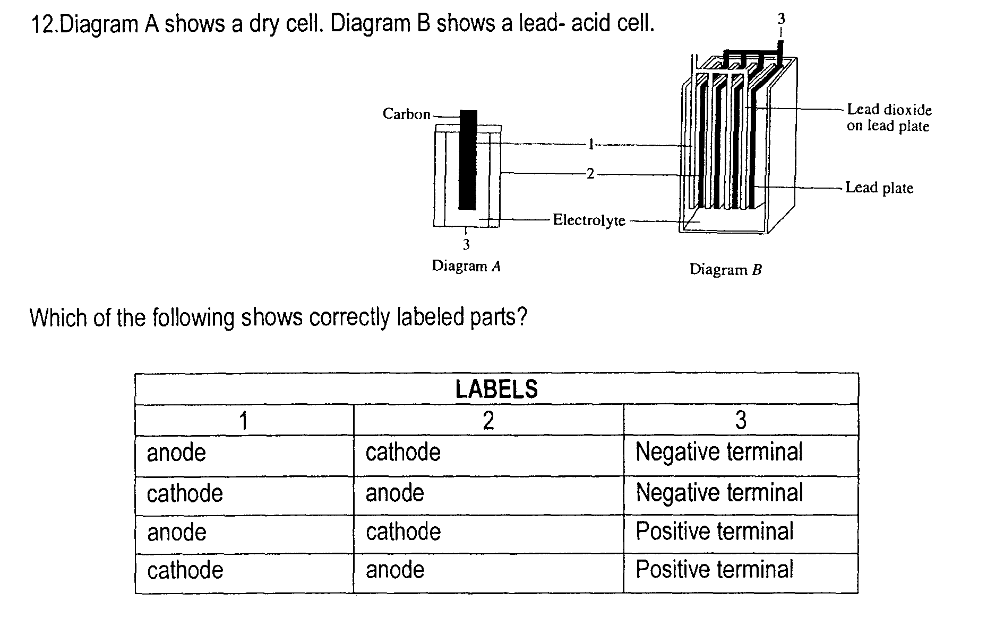

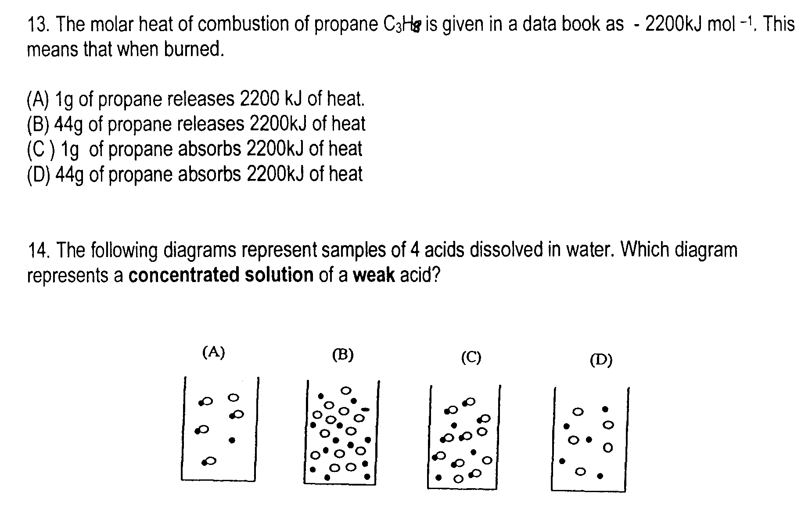

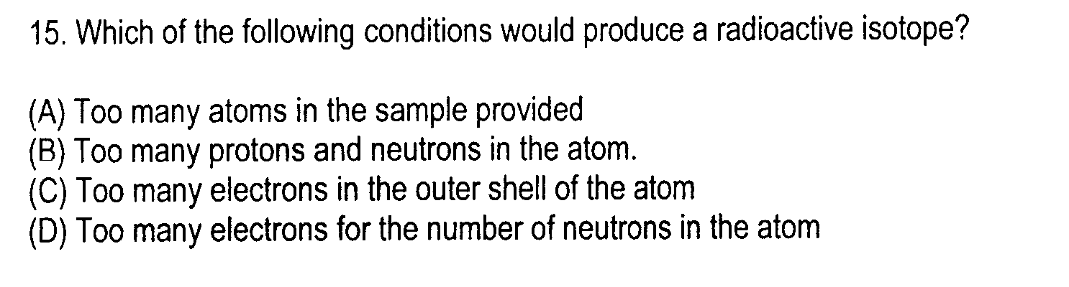

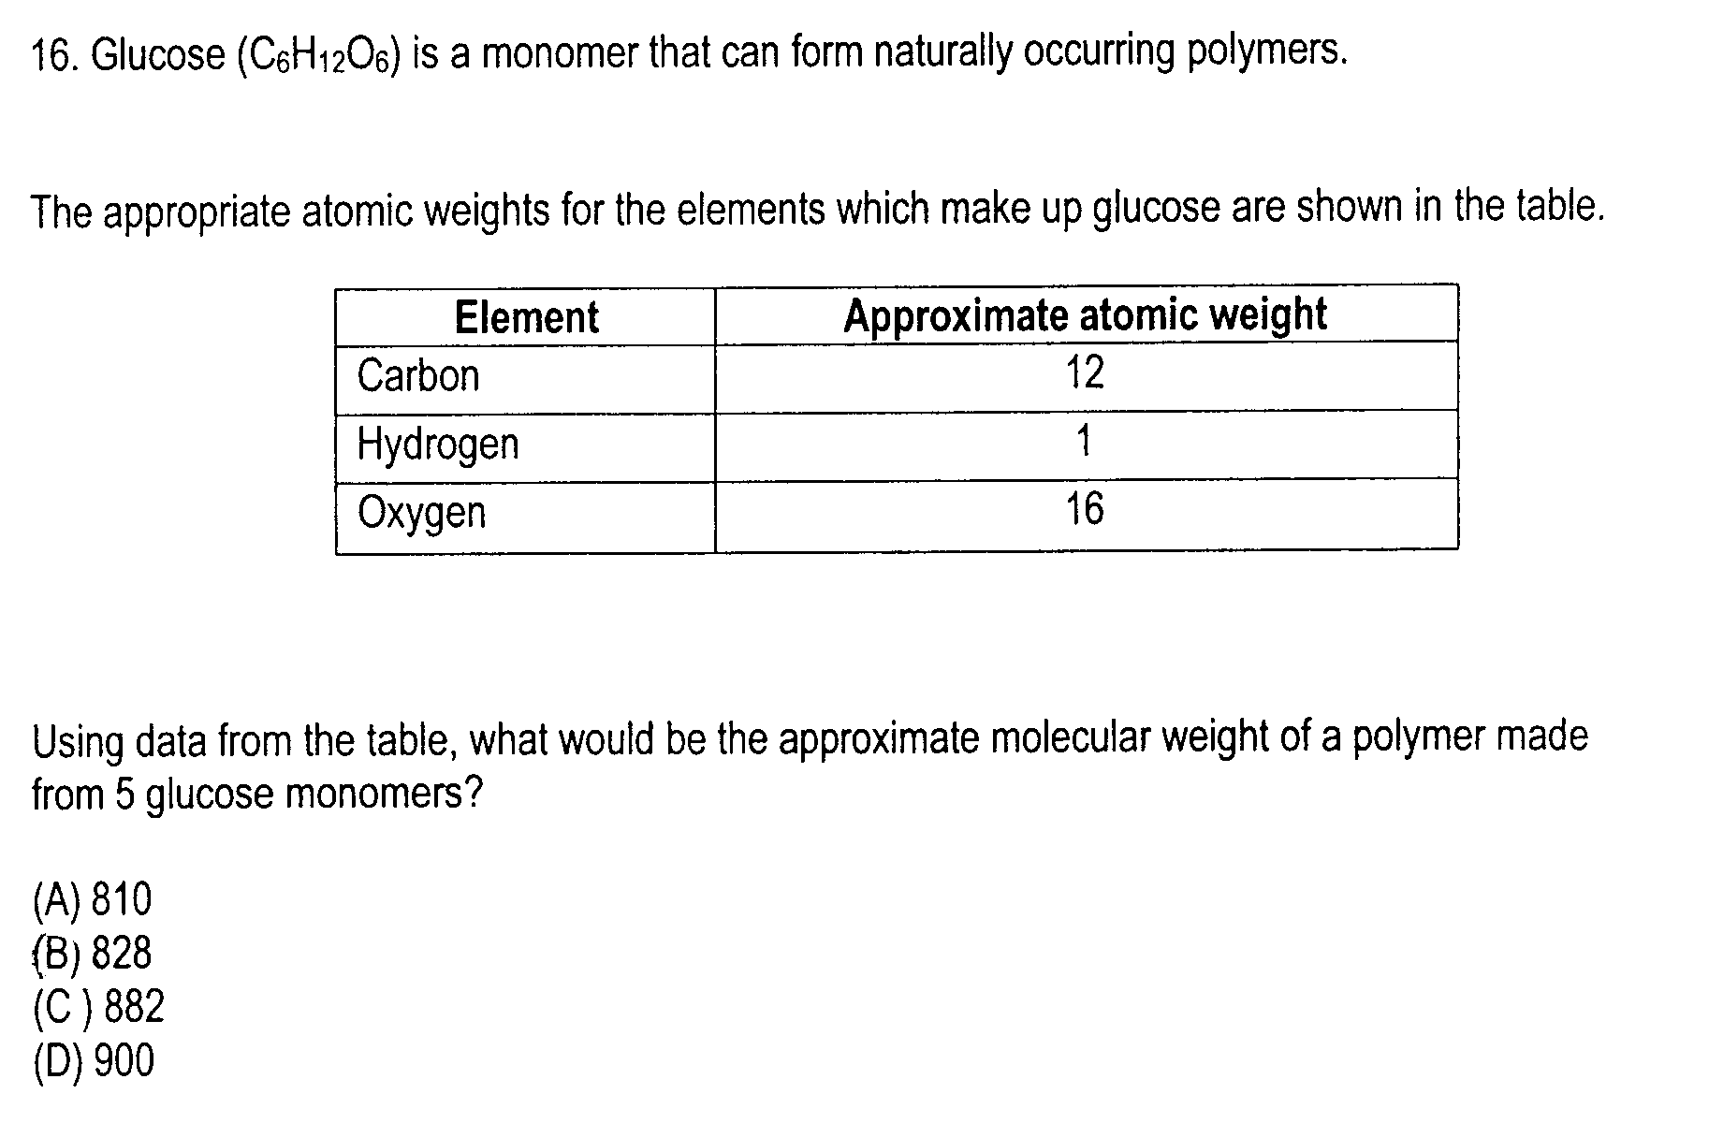
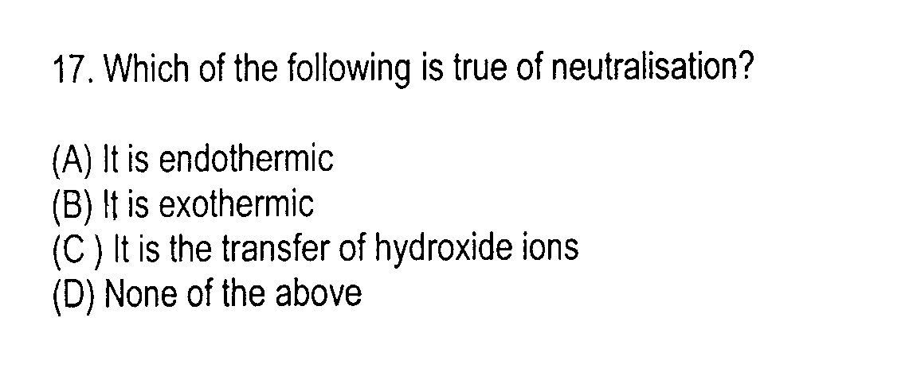
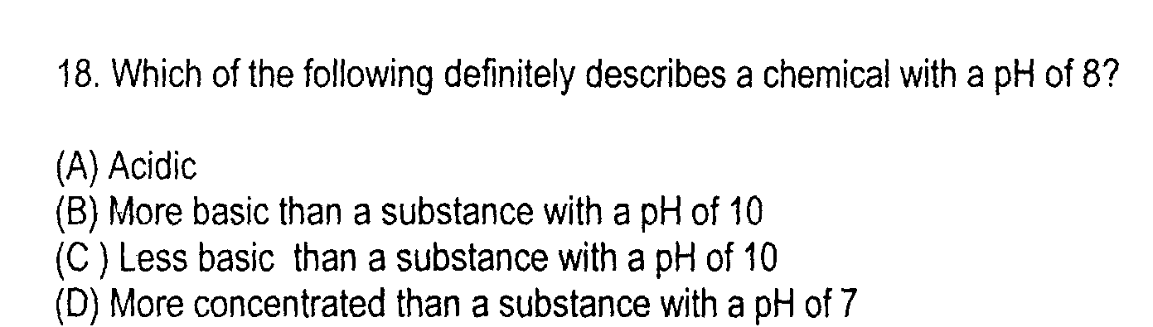
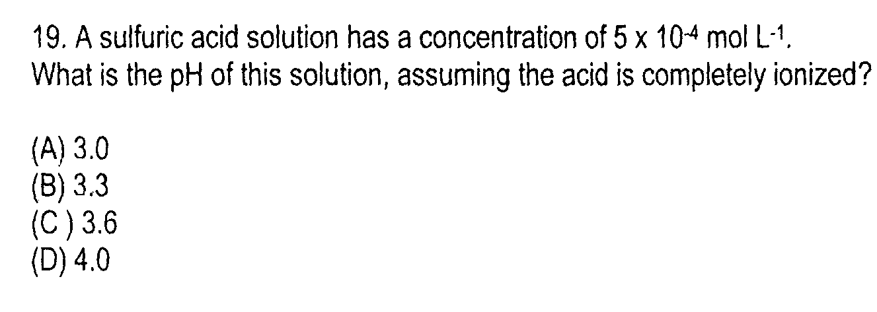
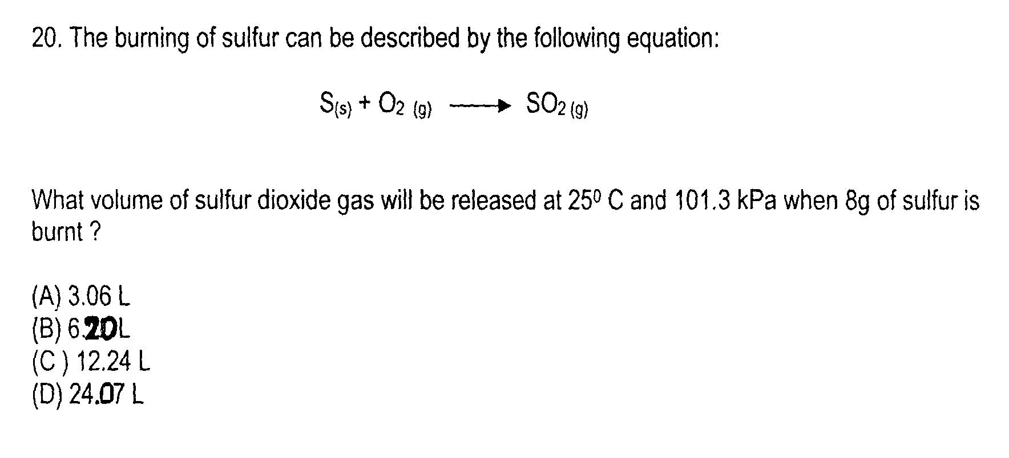

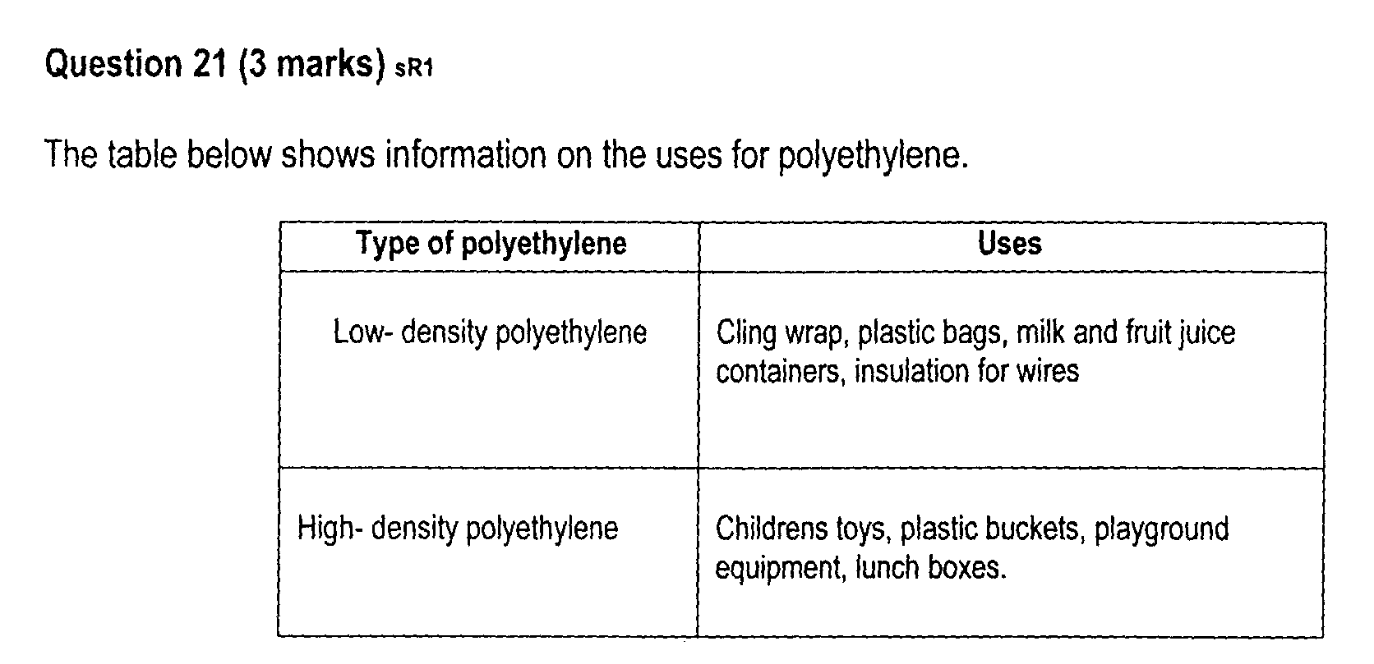

Based on the information in the table, account for the uses of low density polyethylene and high density polyethylene

……………………………………………………………………………………………………………

……………………………………………………………………………………………………………
……………………………………………………………………………………………………………

……………………………………………………………………………………………………………

Question 22 (3 marks)

Radioisotopes are used in industry, medicine and chemical analysis. For ONE of these fields, relate the use of ONE named radioisotope to its properties

……………………………………………………………………………………………………………

……………………………………………………………………………………………………………
……………………………………………………………………………………………………………

……………………………………………………………………………………………………………

Question 23 (6 marks)

A galvanic cell was constructed using two half-cells. One half-cell consisted of silver metal and silver nitrate solution, and the other half cell consisted of nickel metal and a nickel nitrate solution.

(a) Draw a diagram of the galvanic cell, labelling the anode and cathode, and indicate the direction of
electron flow

(b) Calculate the theoretical voltage of this cell 2
………………………………………………………………………………………………………….

……………………………………………………………………………………………………………
……………………………………………………………………………………………………………

……………………………………………………………………………………………………………

(c) The voltage of the cell was measured and found to be 0.80 V. 2

Suggest TWO reasons that would account for the difference between the theoretical and
experimental values

………………………………………………………………………………………………………….

……………………………………………………………………………………………………………
……………………………………………………………………………………………………………

……………………………………………………………………………………………………………

Question 24 (7 marks)

During your study of the module you evaluated the effectiveness of ethanol as a fuel.

(a) Write an equation to show how ethanol can be produced from sugar cane 1

……………………………………………………………………………………………………………

(b) Assess the potential of ethanol as an alternative fuel. In your answer you should refer to the 6
impact on the environment, cost, success of current usage and identify possible future directions
for research

………………………………………………………………………………………………………….

……………………………………………………………………………………………………………
……………………………………………………………………………………………………………

……………………………………………………………………………………………………………

………………………………………………………………………………………………………….

……………………………………………………………………………………………………………
……………………………………………………………………………………………………………

……………………………………………………………………………………………………………

………………………………………………………………………………………………………….

……………………………………………………………………………………………………………
……………………………………………………………………………………………………………

……………………………………………………………………………………………………………

……………………………………………………………………………………………………………
……………………………………………………………………………………………………………

……………………………………………………………………………………………………………

……………………………………………………………………………………………………………

……………………………………………………………………………………………………………

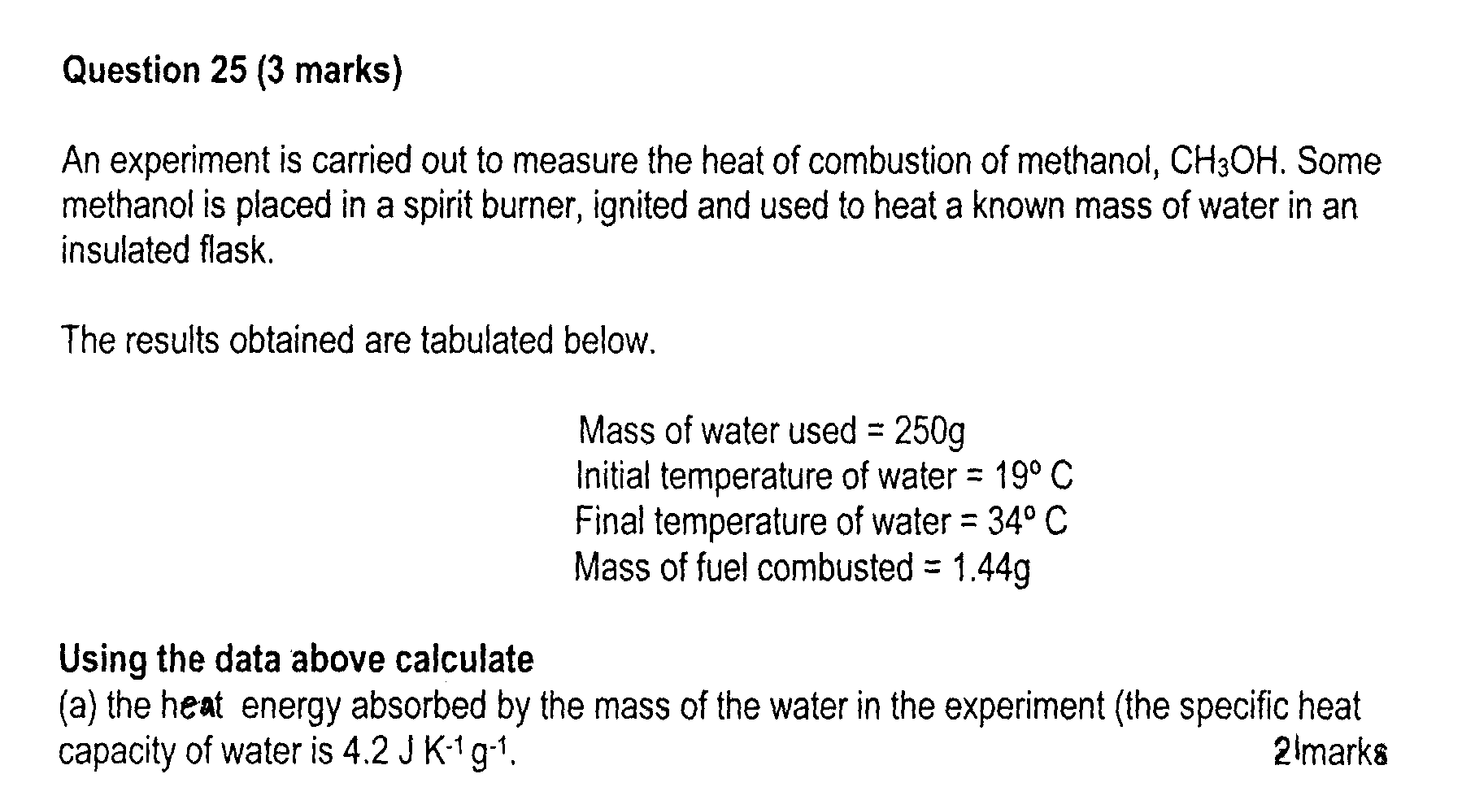

……………………………………………………………………………………………………………

……………………………………………………………………………………………………………

……………………………………………………………………………………………………………

……………………………………………………………………………………………………………

(b) The heat of combustion of methanol in kJ/mole methanol 1

……………………………………………………………………………………………………………

……………………………………………………………………………………………………………

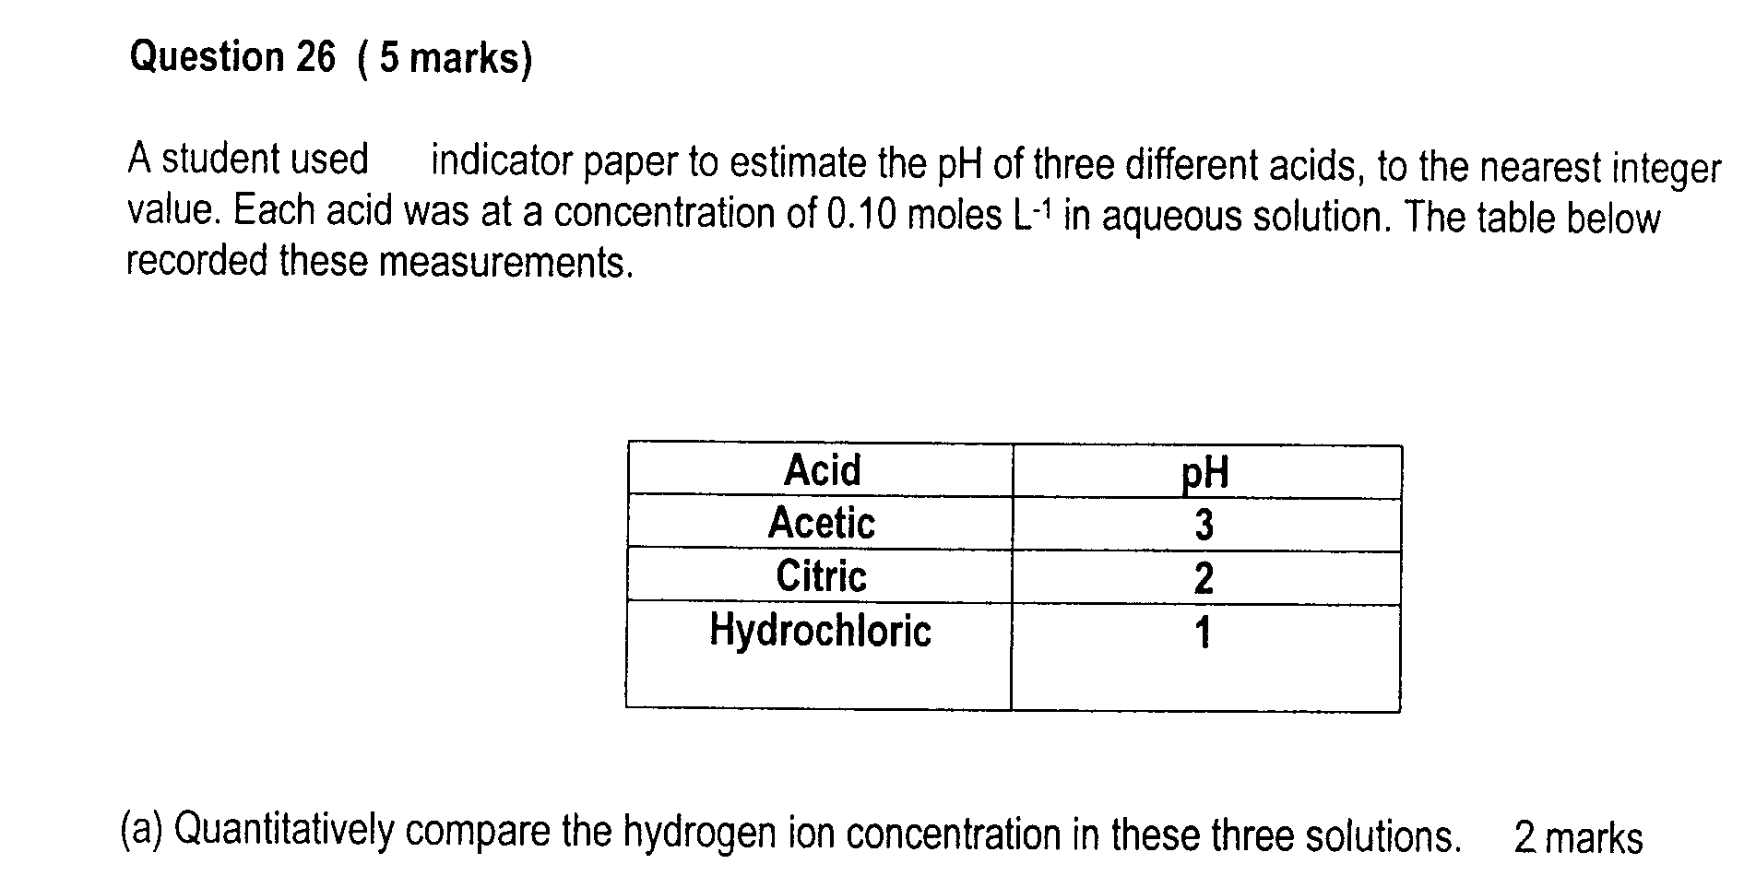
……………………………………………………………………………………………………………

……………………………………………………………………………………………………………

……………………………………………………………………………………………………………

……………………………………………………………………………………………………………

(b) Account for the differences in these values 3

……………………………………………………………………………………………………………

……………………………………………………………………………………………………………

……………………………………………………………………………………………………………

Question 27 (3 marks)

Aluminium reacts with dilute sulfuric acid according to the equation

2Al(s) + 3H₂SO₄(aq) → Al₂(SO₄)₃ + 3H₂(g)

What is the maximum volume of hydrogen measured at 25ºC and 101.3 kPa that can be produced when 5.4 g of aluminium is put into excess sulfuric acid

……………………………………………………………………………………………………………

……………………………………………………………………………………………………………

……………………………………………………………………………………………………………

Question 28 (5 marks)

Explain the formation and effects of acid rain (give at least two causes and two effects)

……………………………………………………………………………………………………………

……………………………………………………………………………………………………………

……………………………………………………………………………………………………………

……………………………………………………………………………………………………………

……………………………………………………………………………………………………………

……………………………………………………………………………………………………………

……………………………………………………………………………………………………………

……………………………………………………………………………………………………………

……………………………………………………………………………………………………………
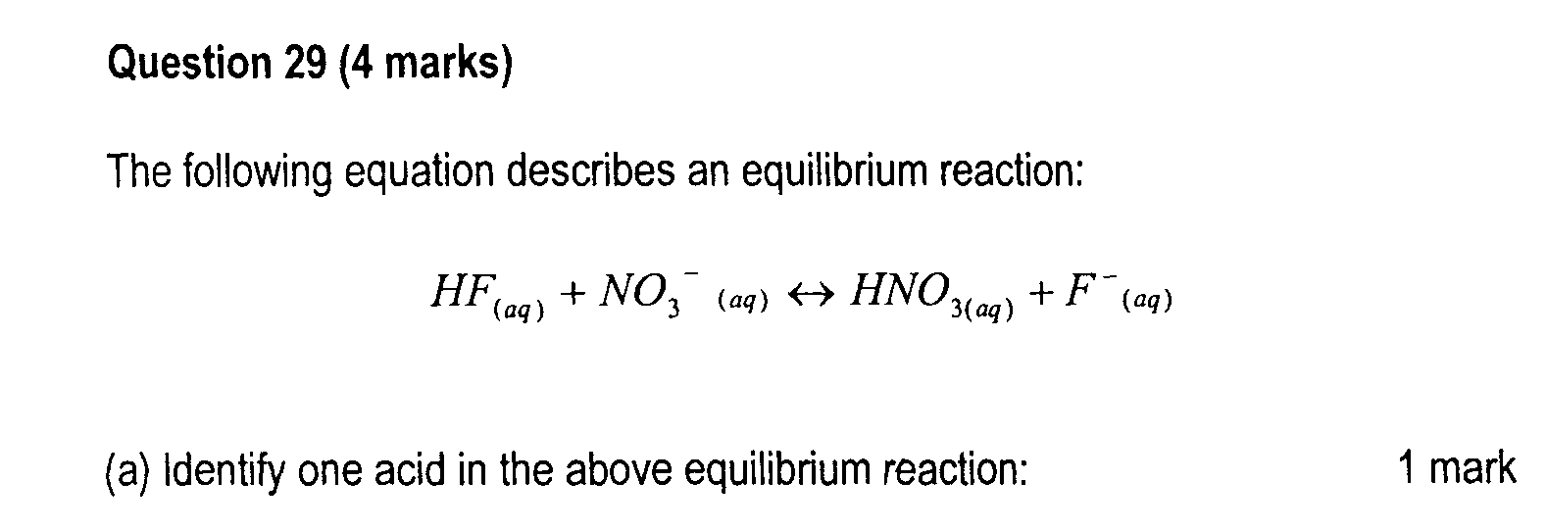

……………………………………………………………………………………………………………
(b) Identify the conjugate base of the named acid in part (a) 1

……………………………………………………………………………………………………………

(c) Describe the effect on the reaction equilibrium of adding potassium nitrate to the solution 2
and explain why this occurs

……………………………………………………………………………………………………………

……………………………………………………………………………………………………………

……………………………………………………………………………………………………………
Question 30 (8 marks)

You have carried out a first hand investigation to compare the reactivity of an alkene with its corresponding alkane

(a) State the name of the alkene 1

……………………………………………………………………………………………………………

(b) Outline the procedure to compare the reactivity of this alkene with its corresponding alkane 2

……………………………………………………………………………………………………………

……………………………………………………………………………………………………………

……………………………………………………………………………………………………………

……………………………………………………………………………………………………………

……………………………………………………………………………………………………………

(c) Explain the results obtained from this first hand investigation with relevant chemical equations 3

……………………………………………………………………………………………………………

……………………………………………………………………………………………………………

……………………………………………………………………………………………………………

……………………………………………………………………………………………………………

……………………………………………………………………………………………………………

……………………………………………………………………………………………………………
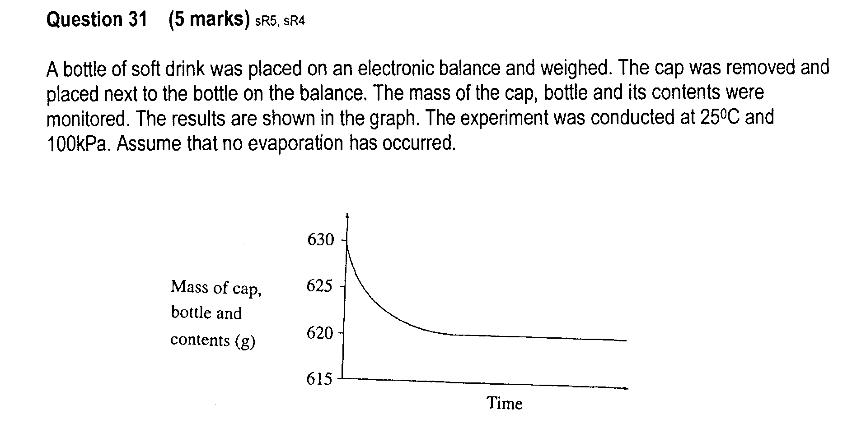

(a) Identify the gas released………………………………………………………………….. 1

(b) Calculate the volume of the gas released 4

……………………………………………………………………………………………………………

……………………………………………………………………………………………………………

……………………………………………………………………………………………………………

